# **Text-to-Speech**

# **Enabling Offline Mode**

Right now all the devices are not supporting offline speech input. However you can follow this discussion to enable offline speech input for supported devices.

I have downloaded speech input packages on my Nexus 5 and offline speech is working fine.

**1**. On your device go to **Settings -> Language and Input**. Click on icon on **Google voice input**.  
**2**. Under **ALL** tab select the language you want to download.  
**3**. Once the language package downloaded, you can see it under **INSTALLED** tab.

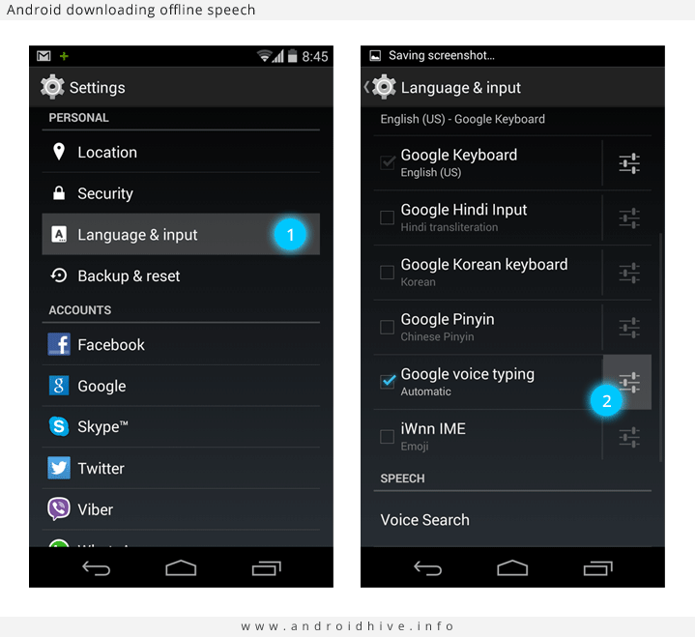

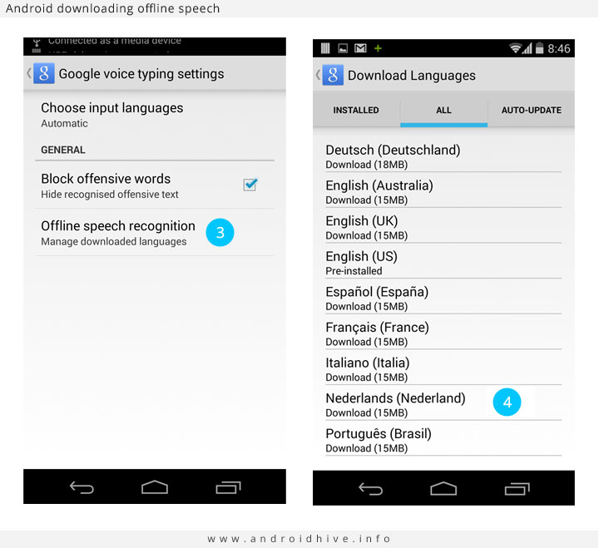

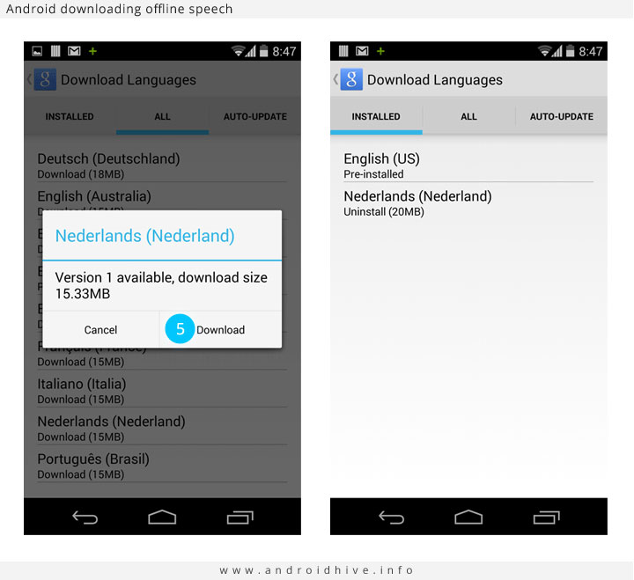

**Speech-to-Text**

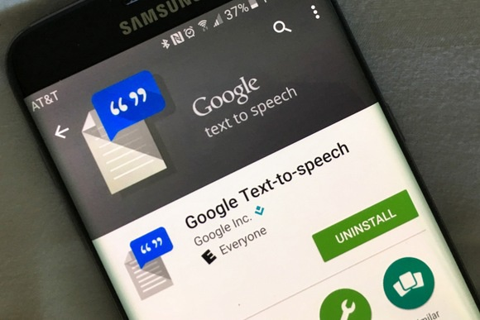

## Part 1: How do I use Google text-to-speech?

Before anything else, you will need to enable Android text-to-speech capabilities from the Android Setting menu. Here is how you can activate Android TTS on your device:

1. Go to the Language and input panel and tap on Text-to-speech options at the bottom of the screen.

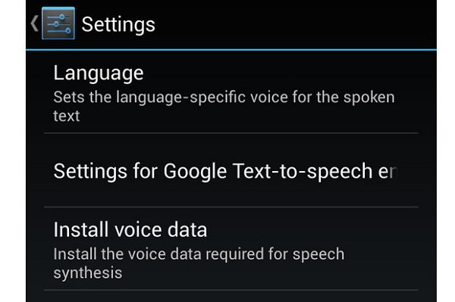

2. Click on your Preferred TTS engine. You will be able to find Google text-to-speech engine, as well as one from your device manufacturer if any.

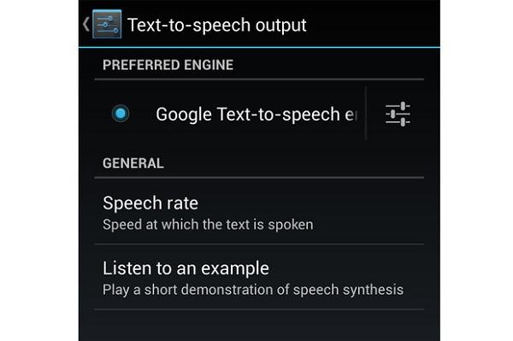

3. On the same window, you are able to customise the Speech rate, Default language status and Listen to an example.

4. You will be able to find a wide range of languages that are supported by the TTS technology.

